Animation improve Highway Code Rules learning in deaf candidates
Sébastien Laurent¹, Jean-Michel Boucheix², Stéphane Argon², Antonio. R. Hidalgo-Munoz¹ & Laurence Paire-Ficout¹
¹Ifsttar-TS2-Lescot, Bron, France,
²LEAD-CNRS, University of Burgundy, Dijon France
sebastien.laurent@ifsttar.fr; Jean-Michel.Boucheix@u-bourgogne.fr;

Abstract.. Research on the effect of animations in multimedia learning of dynamic processes has been focused on school-type educational purposes, however, little work concerned situations outside of schools. The present study tested the potential benefit of using dynamic visualization in learning Highway Code Rules, for candidates preparing the theoretical part of driving license. Conventional learning material of the Highway Code, is based on multimedia static material including written instructions and questions, with single “photo-realistic” pictures of road scenes which do not allow to easily infer the dynamism required to estimate distance and time. This study investigated the effectiveness of animated presentations compared to their static counterparts in a decision making task about traffic rules. The hypothesis was that animation might improve the quality of decision and especially in deaf candidates who may have degraded temporal skills and for whom dynamic presentation could act a compensator device. Four types of driving situations (overtaking, insertion on roundabout, insertion on highway and crossing an intersection) were modeled with 3D Studio real time software. Half of the items were presented in animated format and the other half were presented in sequential static format. Items were also either "simple" (antagonist vehicle was far or very close) or complex (antagonist vehicle position was intermediate between far and close). Across 32 items, participants were asked to decide whether they could insert, overtake or cross an intersection. Correct answers and decision times were recorded. Animation format was superior to sequential-static format in the decision-making task, and the benefit of the animated presentation was higher in the deaf group that in the hearing group.
Keywords: Animation, Highway Code Rules, Deaf learners, Decision making, temporal skills
Introduction
Research on the effect of animations in multimedia learning of dynamic processes has been focused on school-type educational purposes (Höffler & Leutner, 2007, Bernay & Bétrancourt, 2016). Little work concerned situations outside of schools (Schwan, Dutz & Dreger, 2018). The goal of this study was to test the potential benefit of using dynamic visualization in learning Highway Code rules, for candidates preparing the theoretical part of driving license. The conventional material is based on static multimedia material including written questions with single “realistic” photos of road scenes. This material may be effective for learning rules in unconditional road situation, such as recognizing road sign meaning (red traffic light, stop sign etc.). However, many other road situations are less unconditional and require to quickly activating an accurate dynamic representation in order to estimate distances and times of the incoming vehicle and take an accurate anticipatory decision. This is the case of road situations such as overtaking the front car, inserting on roundabout, inserting on highway and crossing an intersection (Fig.1). In these situations, in the presence of another car, a dynamic presentation of the road situation, might foster learning to take more accurate and safe decisions. Animated presentation of road situation would be especially helpful for candidates who may meet difficulties in building dynamic mental models from static pictures. Such assumption could be relevant with regard to deaf candidates, who have more difficulties than hearing candidates to succeed the theoretical exam. Previous research suggest that, apart from reading, one of the main difficulty in deaf people origins in their ability to process and segment temporal information. Cognitive abilities related to learning, recalling, and producing temporal information may be impaired (Conway & al.2007, 2009). In the present study, we compared the effectiveness of dynamic vs. static presentation formats of road scenes on the accuracy of answers in a decision making task. We expected better decisions about road situations in animated presentation than in static presentation, in both hearing and deaf candidates. We especially expected an improvement among deaf learners. Since animation seems to be able to compensate for low spatial capacities (Höffler & Leutner, 2011), animation could also compensate for low temporal sequencing abilities, supporting the hypothesis of capacity as a compensator?

Method
The forty-five participants in the study were involved in traffic rules learning sessions to preparing the Highway Code examination in a driving school: 21 were deaf (M = 32 years old) 24 hearing (M = 20). With regards to their social and educational levels the two groups were comparable as well as regarding their prior knowledge in the tested Highway Code rules. The present experimental study took place apart from the driving school lessons. The animated material consisted in four types of driving situations (overtaking, insertion on roundabout, insertion on highway and crossing an intersection, Error: Reference source not found) modeled with real time 3D software in accordance to French norms road. Two formats were created: dynamic vs. static- sequential. Real time for cars distance and speed was used. Road situations corresponded to the moments-time just preceding the expected decision (overtake, insert or cross). For each driving situation, four versions of different “complexity” were designed, in which the spatial-temporal distance between the driver’s car and the antagonist vehicle was manipulated. The four versions were created to make two “yes, I can” answers and two “no, I cannot” answers. For each yes or no answer, in half the cases the answer was considered “simple“ (without ambiguity, because the antagonist vehicle was very far or very close) whereas in other half the response was considered “complex” (the antagonist vehicle distance was intermediate between very far and very close, speed was constant). The relevance of these categories was based on a pre-test with experienced driving teacher's judgments. Animated items were replicated according four contextual raod environments for a total of 64 items. In order to create the sequential-static format, from each animation three static pictures were extracted across the animation time: the first at the starting time of the animation, the last at the ending time of the animation and the second picture was taken in the middle of the animation time (see Error: Reference source not found). A total of 128 items were designed and split into 4 lists, each divided into two blocks, 16 animated and 16 sequential-static items: 32 items were showed to each participant. A counterbalancing and randomized technique was applied to control order effect. In each group (deaf vs. hearing), format (Dynamic vs. Static-sequential) and complexity were within group factors. Participants were tested individually and for each road situation item, they were invited to decide whether or not they could (were allowed to and had enough time to) make the action (by pressing a yes or no button). Each item was presented 8 seconds. Accuracy and response time were recorded. Instructions and questions were presented in both written form and sign language for deaf participants.

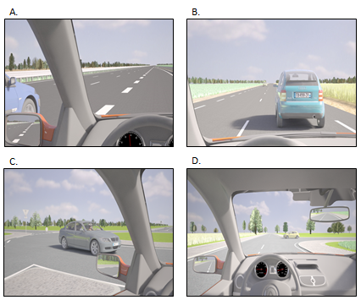
Fig. 1. Screenshots of the four dynamic situations before the expected decision (the same environmental context), a: Insertion on highway, b: Overtaking, c: Insertion on Roundabout,
d: Crossing an intersection.

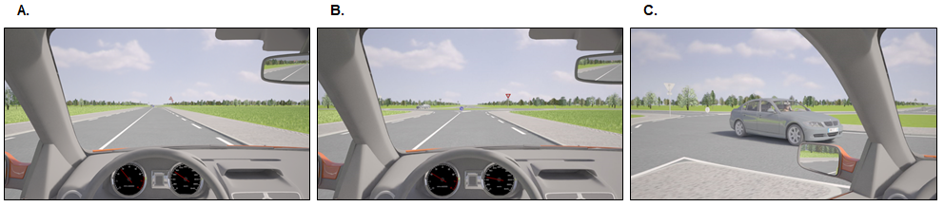
Fig. 2. Example of sequential-static format about an insertion on roundabout situation,
a : First picture , b : Second picture , c : Third picture.

Results
ANOVAs showed deaf made more errors than hearing participants F (1, 43) = 7.25, p = 0.01, η_{p}² = 0.14, (Fig. 3). Error rate was lower in the animated format than in the sequential-static format, F (1, 43) = 4.39, p = 0.04, η_{p}² = 0.09; and also lower in the simple than in the complex road situations, F (1, 43) = 62.86, p < 0.001, η_{p}² = 0.59. There was a significant difference between animated and static-sequential format in the deaf participants group only, F (1, 43) = 5.05, p = 0.03. Less error occurred in animated than in sequential-static format, only in complex road situations, p = 0.006. Further, deaf participants took more time to answer than hearing participants, (1, 43) = 21.02, p < 0.001, η_{p}² = 0.33), in both sequential-static and animated format.

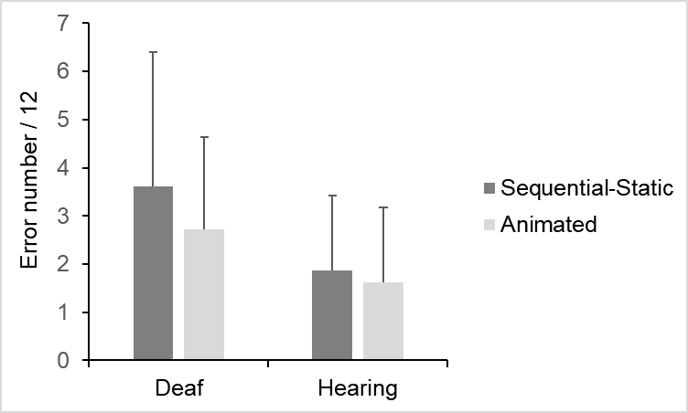
Fig. 3. Mean number of decision making errors, for each presentation format (sequential vs. animated) and in each group participants (deaf vs. hearing).

Conclusion
The benefit of the animated presentation over the static presentation was higher in the deaf group that in the hearing group. This result supports animated format as ability-as-compensator hypothesis; however, here, not for spatial ability (Höffler & Leutner, 2011) but for temporal processing ability.

References
Conway, C. M., Pisoni, D. B., & Kronenberger, W. G. (2009). The Importance of Sound for Cognitive Sequencing Abilities. Current Directions in Psychological Science, 18, 275-279. https://doi.org/10.1111/j.1467-8721.2009.01651.x

Höffler, T. N., & Leutner, D. (2011). The role of spatial ability in learning from instructional animations–Evidence for an ability-as-compensator hypothesis. Computers in human behavior, 27(1), 209–216.

